*Florida International University*

*School of Computing and Information Sciences*

Software Engineering Focus

Feature Document

User Story ID <NVOS-14 Ontology Search Function >

**Name:** Bryan Bastida

**Team Member(s):** Bryan Bastida

Andrew Castillo

**Project:** Envo Scholar

**Product Owner(s)**: Mark Finlayson

**Mentor(s)**: Masoud Sadjadi

**Instructor**: Masoud Sadjadi

**User Story Name:** Ontology Search Function

* Description: As a user, I want access to a search function for the ontology, so that I can search for a specific concept.

Acceptance Criteria

* User has pressed on the Ontology tab from the homepage
* The ontology page opens
* The user types the concept he/she is looking for in the search bar and the tree expands to the concept they typed.

**Use Case**

* **Name**: Ontology Search Function
* **Actor**: User and Web page
* **Preconditions**: User has accessed the Envo Scholar website

User has clicked on the Ontology tab

* **Postconditions**: User is able to type a concept into the search bar and click search

The verticle tree will expand to the concept they searched for

* **Description** <Flow of events>:
  + User accesses the Envo Scholar website
  + User clicks on the Ontology tab
  + Page changes from homepage to ontology
  + User types a concept into the search bar
  + The verticle tree will expand to the concept they searched for

**Use Case Diagram**

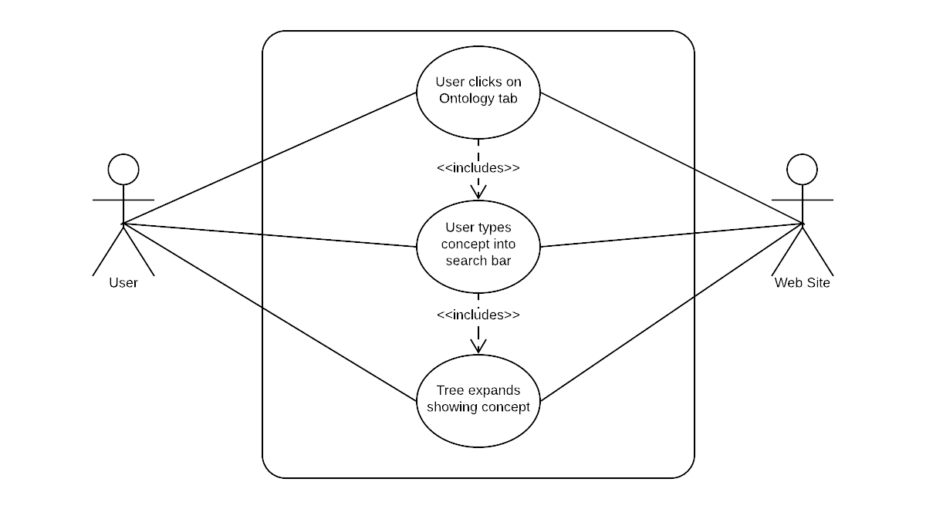

**Sequence Diagram**

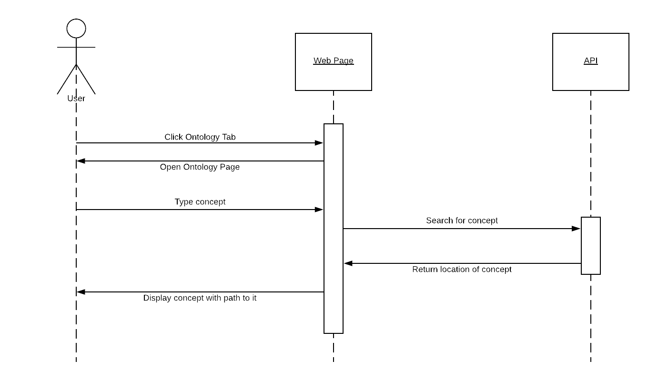

**Class Diagram**

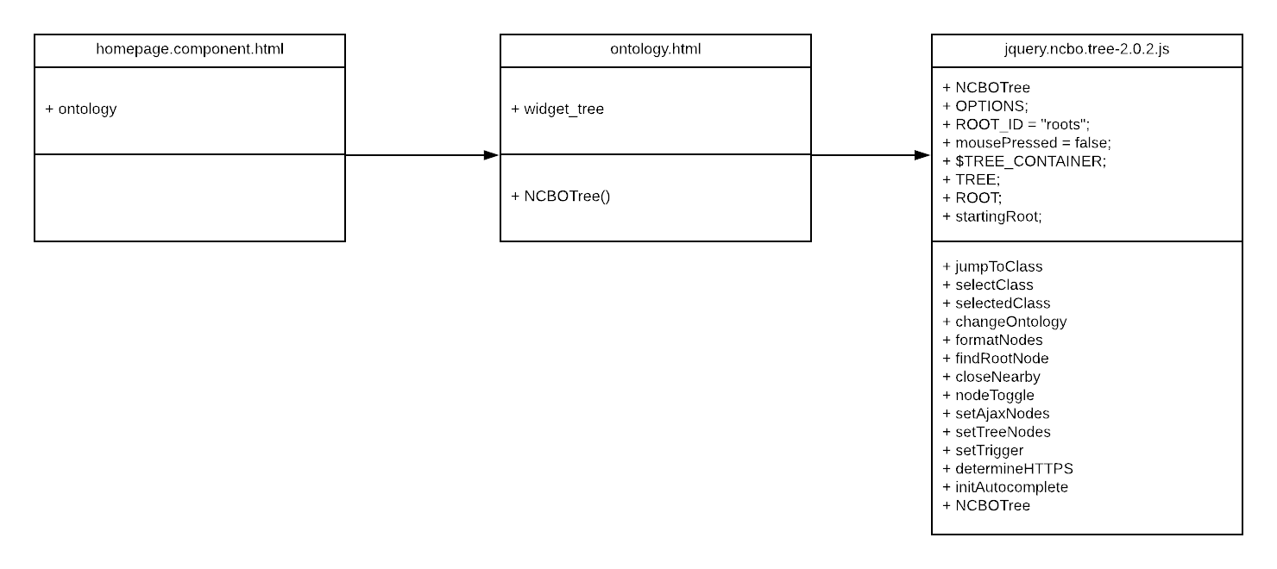

## ****Unit Test****

* Test case ID: NVOS-14-Ontology-Search-Function
* Description/Summary of Test: User types a concept. The tree expands showing the path to that concept.
* Pre-condition: User types a concept.
* Expected Results: The tree expands showing the path to that concept.
* Actual Result: The tree expands showing the path to that concept.
* Status (Fail/Pass): Pass

**Visual User Guide**

